**NAME-vikramaye**

**UID-19BCS3765**

**BRANCH-CSE Big Data-1(GROUP A)**

**AIM=Design a system with 5 poles for Highway Lighting such that whenever a car crosses through a pole, the LED installed on it starts blinking (only during night) at a rate twice that of previous pole.**

**CIRCUIT DIAGRAM=**

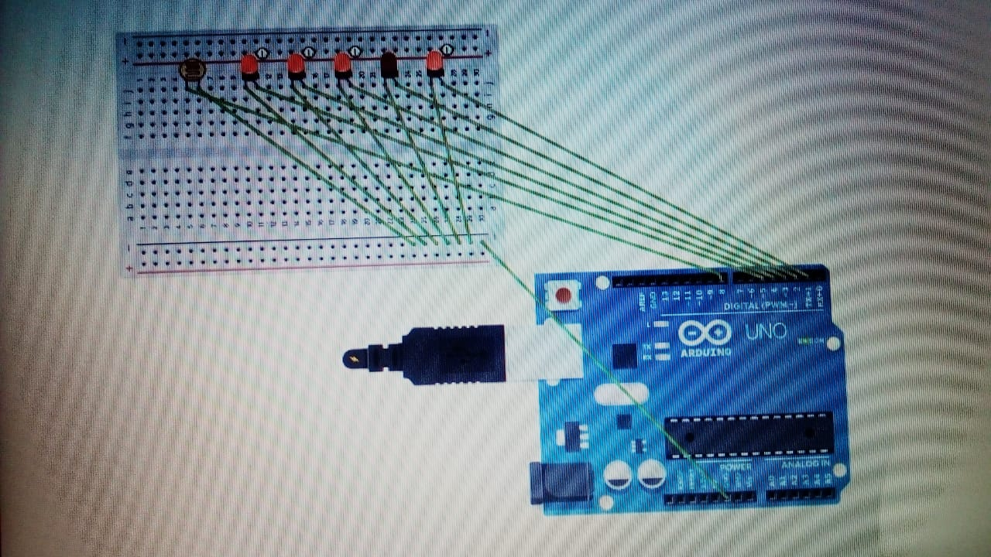

**THEORY=**

**Arduino: Arduino is an open-source electronics platform based on easy-to-use hardware and software.** [**Arduino boards**](https://www.arduino.cc/en/Main/Products) **are able to read inputs - light on a sensor, a finger on a button, or a Twitter message - and turn it into an output - activating a motor, turning on an LED, publishing something online. You can tell your board what to do by sending a set of instructions to the microcontroller on the board. To do so you use the** [**Arduino programming language**](https://www.arduino.cc/en/Reference/HomePage) **(based on** [**Wiring**](http://wiring.org.co/)**), and** [**the Arduino Software (IDE)**](https://www.arduino.cc/en/Main/Software)**, based on** [**Processing**](https://processing.org/)**.**

**In this we connected 5 LED’S to Arduino board. This is used for safety. Here when the car crosses through a pole then the LED will lighten up and next LED will lighten up with the twice the rate of the first LED.**

**LEARNING AND OBSERVATION=**

**1. Whenever a car crosses through a pole, the LED installed on it starts blinking.**

**2. Whenever a car crosses through a pole, the LED installed on it stops blinking.**

**3. 2nd LED installed on it starts blinking (only during night) at a rate twice that of previous pole.**

**PROBLEM AND TROUBLESHOOTING=**

**1. Setting up of connections.**

**2. Error’s in code.**

**3. Port was not selected.**

**PRECAUTIONS=**

**1. Don’t plug in a LED without a current limiting resistor.**

**2. Don’t supply high voltage.**

**3. Circuit must be correct.**

**LEARNING OUTCOMES=**

**1. Came to know about the working of Arduino.**

**2. Came to know how we can build up our own project using Arduino.**

**3. Learn’t C programming along with Arduino.**